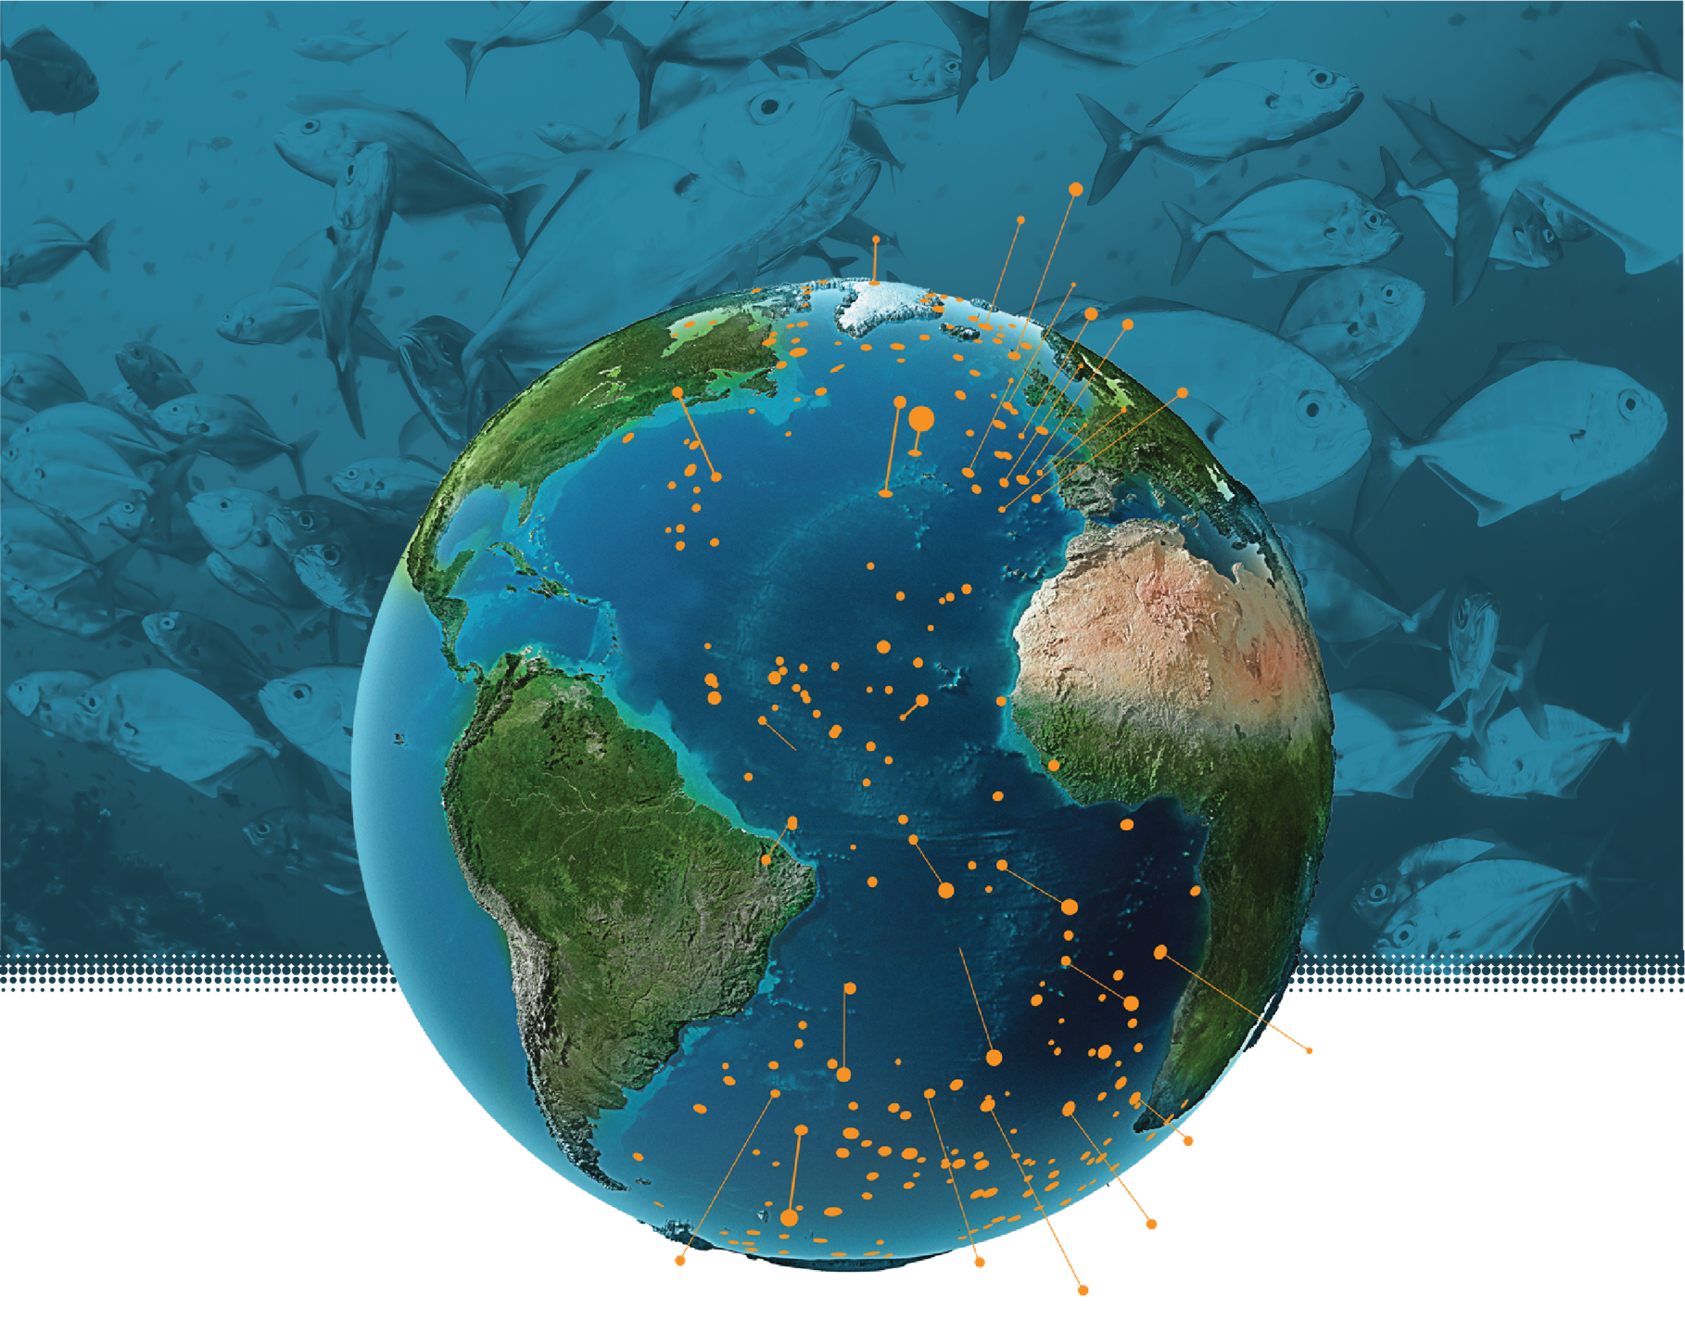

Content Submission Template
All-Atlantic Ocean Research and Innovation Alliance

All-Atlantic Ocean Research and Innovation Alliance - Content Submission Template
We invite contributions to the All-Atlantic Ocean Research and Innovation Alliance (AAORIA) communication efforts by all AAORIA Partners and Supporters. Please share your latest news, updates, events, and/or achievements with us! You can use this template to submit your article and ensure all fields are completed to help us create engaging and informative content. The information you provide will be used to populate the All-Atlantic website, social media channels and newsletter.

CATEGORY
Please choose the most relevant categories for your submission.
☐ Events (Conferences, Symposia, Workshops etc.)
☐ Job opportunities, Internships and/or Training Programs
☐ Research Papers/Scientific Publications
☐ All-Atlantic Area of Action update
☐ Coastal Resilience
☐ Ocean Observing and Modelling
☐ All-Atlantic Declaration Priorities (please specify which one here:_______)
☐ All-Atlantic Joint Action or Working Group update (please specify which one here:_______)
☐ All-Atlantic Project update (please specify which one here:_______)
☐ Success story spotlighting Atlantic cooperation
☐ Stakeholder Engagement
☐ Other (Please specify)

TITLE
Provide a brief and engaging title for your article.

Title:

SUMMARY
Please provide a brief summary of your article. This should be no more than 3-4 sentences summarising the key message.

Summary:

TEXT
Kindly provide the complete text of your article, ensuring clarity by organising it into well-structured paragraphs. Focus on the core message you wish to convey, including any pertinent details, links, and context that will help the All-Atlantic community fully understand your piece of news and its significance. The article will be featured on the All-Atlantic website, and a concise summary will be shared on our social media channels and newsletter, directing readers to the full article on the website. If your article has already been published elsewhere, feel free to paraphrase it here or simply share the original publication link.

Complete text:
Links:

PHOTOS
Attach at least one high-quality image, with one side at least 800 pixels. Images should be in .jpg or .png format. Please ensure it follows GDPR and copyright regulations.

Please fill in the following required information:
- Short photo description:
- Photo credits (Who took this photo? Does it belong to anyone? Is it under any copyright licence?):
- GDPR & copyright permissions: by submitting, you confirm the attached images are available for use with the appropriate Creative Commons license and meet all GDPR, health, safety, and copyright standards.

CONTACT INFORMATION
Please provide your contact details for any follow-up or clarification.
- Name:
- Email:
- Affiliation/Institution:

ADDITIONAL NOTES AND/OR COMMENTS
Please Include any additional comments, disclaimers, or specific requests for how the article or images should be used.

SUBMISSION GUIDELINES
Please fill in the form in its entirety and then send the finalised file in .word format and the attached image in .jpg or .png format to lisa.picatto@jpi-oceans.eu and okeanocoordination@marine.ie. Additional documents can be sent in .pdf format to the same email addresses.

Thank you for your contribution to the All-Atlantic communication efforts. We look forward to sharing your updates with our community!

For any questions, please contact lisa.picatto@jpi-oceans.eu and okeanocoordination@marine.ie

The communication efforts are under Work Package 5 (WP5) on All-Atlantic Communication, Dissemination and Outreach of the OKEANO Coordination & Support Action (CSA). OKEANO is supporting the All-Atlantic Ocean Research and Innovation Alliance and Declaration. It has received funding from the European Union’s Horizon Europe Research and Innovation Programme under Grant Agreement No. 101158065.



